Assignment 9

* Create a *StatefulWidget* that displays an image. The image should be centered on the screen. The image should change to another image when the user presses a button. You need to add five different images in the *assets* folder. When the user reaches the last image, the image should change back to the first image.
* 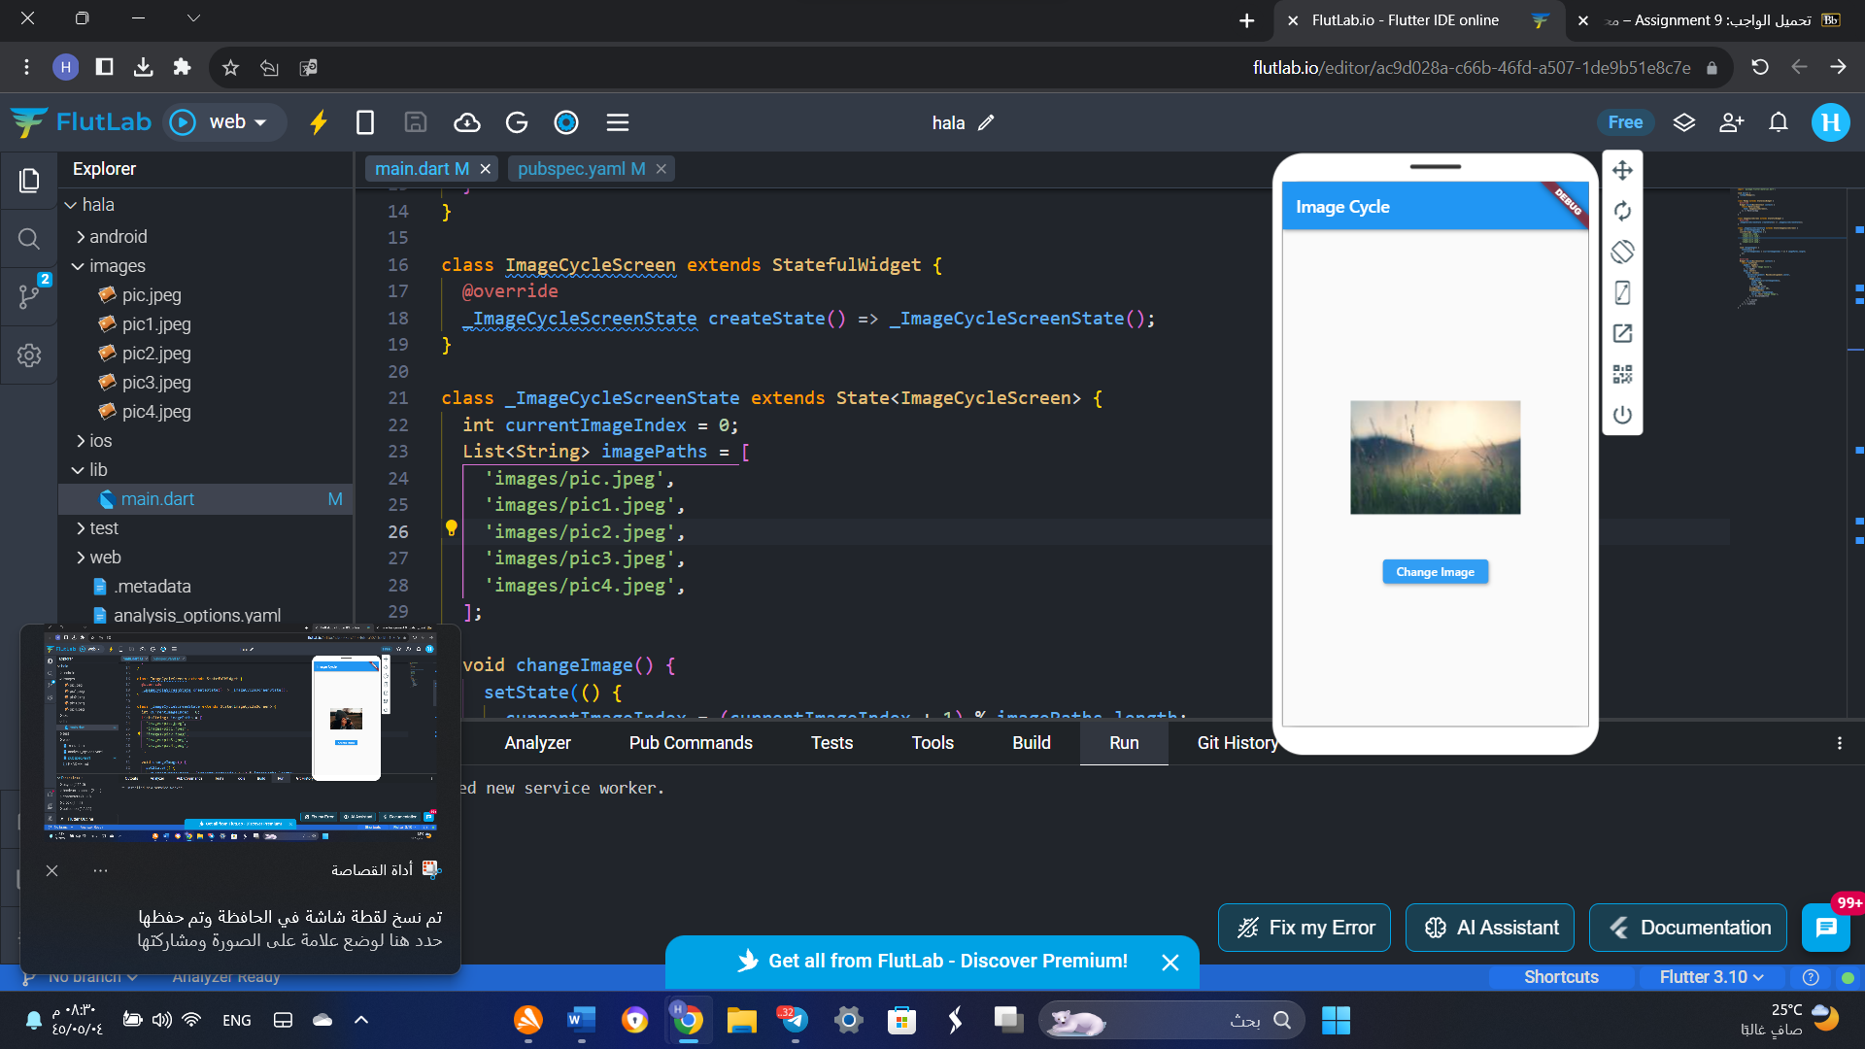
* import 'package:flutter/material.dart';
* void main() {
* runApp(MyApp());
* }
* class MyApp extends StatelessWidget {
* @override
* Widget build(BuildContext context) {
* return MaterialApp(
* home: ImageCycleScreen(),
* );
* }
* }
* class ImageCycleScreen extends StatefulWidget {
* @override
* _ImageCycleScreenState createState() => _ImageCycleScreenState();
* }
* class _ImageCycleScreenState extends State<ImageCycleScreen> {
* int currentImageIndex = 0;
* List<String> imagePaths = [
* 'images/pic.jpeg',
* 'images/pic1.jpeg',
* 'images/pic2.jpeg',
* 'images/pic3.jpeg',
* 'images/pic4.jpeg',
* ];
* void changeImage() {
* setState(() {
* currentImageIndex = (currentImageIndex + 1) % imagePaths.length;
* });
* }
* @override
* Widget build(BuildContext context) {
* return Scaffold(
* appBar: AppBar(
* title: Text('Image Cycle'),
* ),
* body: Center(
* child: Column(
* mainAxisAlignment: MainAxisAlignment.center,
* children: [
* Image.asset(
* imagePaths[currentImageIndex],
* width: 200,
* height: 200,
* ),
* SizedBox(height: 20),
* ElevatedButton(
* onPressed: changeImage,
* child: Text('Change Image'),
* ),
* ],
* ),
* ),
* );
* }
* }
* 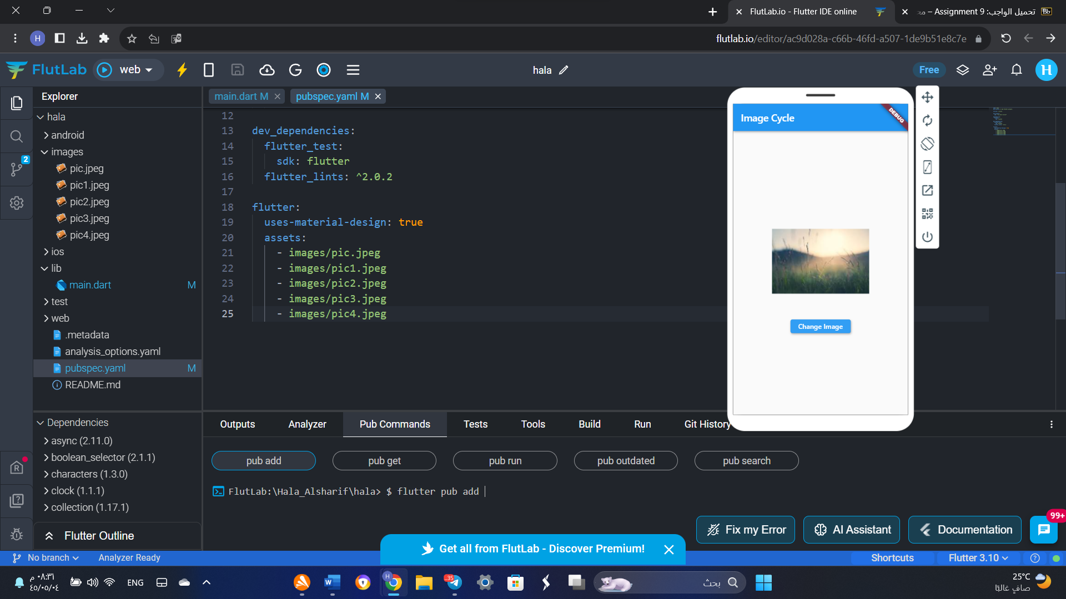
* Reformat the code from the previous exercise to display the images in a random order. In other words, the images should be displayed in a random order every time the user presses the button. 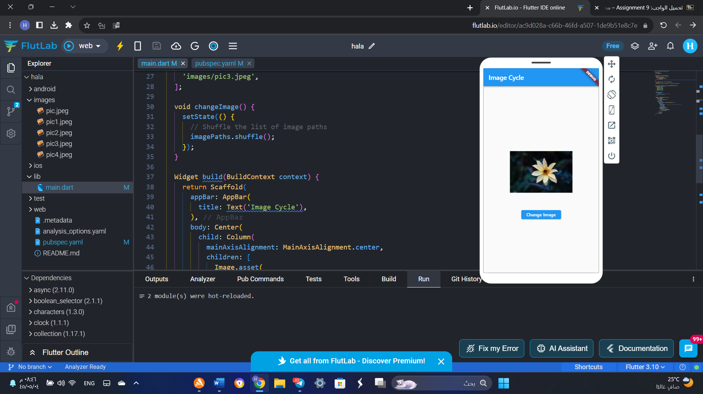
* import 'package:flutter/material.dart';
* void main() {
* runApp(MyApp());
* }
* class MyApp extends StatelessWidget {
* @override
* Widget build(BuildContext context) {
* return MaterialApp(
* home: ImageCycleScreen(),
* );
* }
* }
* class ImageCycleScreen extends StatefulWidget {
* @override
* _ImageCycleScreenState createState() => _ImageCycleScreenState();
* }
* class _ImageCycleScreenState extends State<ImageCycleScreen> {
* List<String> imagePaths = [
* 'images/pic.jpeg',
* 'images/pic1.jpeg',
* 'images/pic2.jpeg',
* 'images/pic4.jpeg',
* 'images/pic3.jpeg',
* ];
* void changeImage() {
* setState(() {
* // Shuffle the list of image paths
* imagePaths.shuffle();
* });
* }
* Widget build(BuildContext context) {
* return Scaffold(
* appBar: AppBar(
* title: Text('Image Cycle'),
* ),
* body: Center(
* child: Column(
* mainAxisAlignment: MainAxisAlignment.center,
* children: [
* Image.asset(
* imagePaths[0], // Display the first image after shuffling
* width: 200,
* height: 200,
* ),
* SizedBox(height: 20),
* ElevatedButton(
* onPressed: changeImage,
* child: Text('Change Image'),
* ),
* ],
* ),
* ),
* );
* }
* }